**11. ReactJS-HOL**

The objective of this HandsOn is to explore various event handling techniques in React using functional components and hooks within a React application “eventexamplesapp”.

**Steps followed :**

1. Created the React App –

I created a new React app ‘eventexamplesapp’ using command :

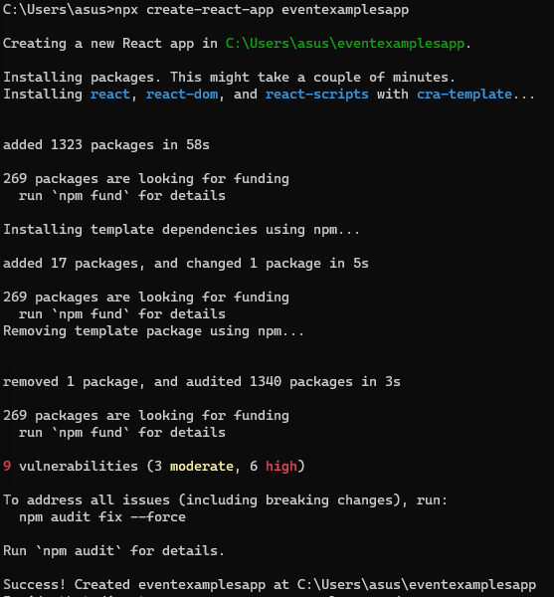

1. Opened the Project in VS Code –

Using command in command prompt :

1. Components used –

Inside the src folder, we created 2 .js files :

1. Created Counter.js :

import React, { useState } from 'react';

function Counter() {

const [count, setCount] = useState(1);

const increment = () => {

setCount(prev => prev + 1);

sayHello();

};

const decrement = () => {

setCount(prev => prev - 1);

};

const sayHello = () => {

alert("Hello! Static message.");

};

const sayWelcome = (message) => {

alert(`Welcome: ${message}`);

};

const handleClick = () => {

alert("I was clicked!");

};

return (

<div>

<h2>{count}</h2>

<div>

<button onClick={increment}>Increment</button>

</div>

<div style={{ marginTop: '8px' }}>

<button onClick={decrement}>Decrement</button>

</div>

<div style={{ marginTop: '8px' }}>

<button onClick={() => sayWelcome("welcome")}>Say welcome</button>

</div>

<div style={{ marginTop: '8px' }}>

<button onClick={handleClick}>Click on me</button>

</div>

</div>

);

}

export default Counter;

1. Created CurrencyConvertor.js –

import React, { useState } from 'react';

function CurrencyConvertor() {

const [amount, setAmount] = useState('');

const [currency, setCurrency] = useState('Euro');

const handleSubmit = (e) => {

e.preventDefault();

const convertedAmount = amount * 80;

alert(`Converting to ${currency} Amount is ${convertedAmount}`);

};

return (

<div>

<h2 style={{ color: 'green' }}>Currency Convertor!!!</h2>

<form onSubmit={handleSubmit}>

<div>

<label>Amount: </label>

<input

type="text"

value={amount}

onChange={(e) => setAmount(e.target.value)}

/>

</div>

<div>

<label>Currency: </label>

<input

type="text"

value={currency}

onChange={(e) => setCurrency(e.target.value)}

/>

</div>

<button type="submit">Submit</button>

</form>

</div>

);

}

export default CurrencyConvertor;

1. Updated App.js –

import React from 'react';

import Counter from './Counter';

import CurrencyConvertor from './CurrencyConvertor';

function App() {

return (

<div className="App">

<Counter />

<hr />

<CurrencyConvertor />

</div>

);

}

export default App;

1. Ran the App –

1. Output –

